**Final Project Hints:**

Block diagram to implement in Simulink:

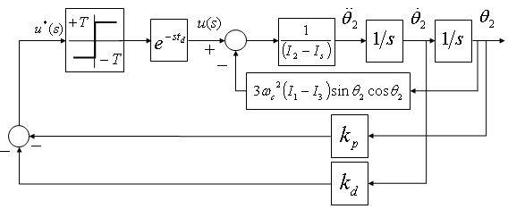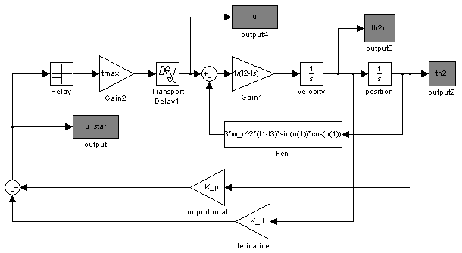

% define the Laplace variable

s = tf('s');

% thruster time delay

td = .1; % time delay

delay = exp(-td*s);

% define PD controller

K = K_p + K_d*s;

% combine G and K

GK = minreal(G*K);

% predict the limit cycle response

[gm,ph,wgm,wpm]=margin(GK*delay);

% for relay nonlinearity, N(A) = 4T/piA

% set N(A) = gain margin and solve for amplitude of limit cycle

A = 4*tmax/(pi*gm);

% plot predicted vs. actual limit cycle

plot(t/60,u_star*(180/pi),t/60,A*sin(wgm.*t)*(180/pi));

Phase Plane Plots for Increasing 









**Final Project Hints:**

**Analysis diagram:**

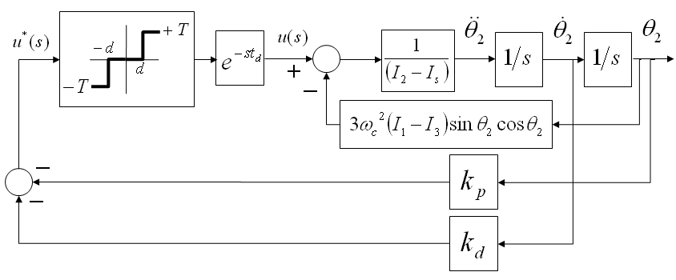

**Block diagram to implement in Simulink:**

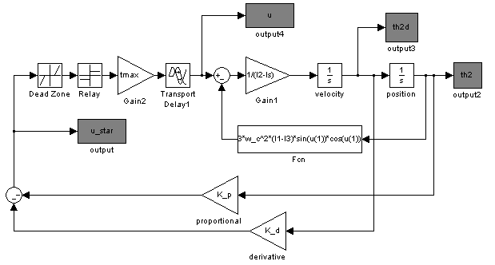

**Switching response near origin with small deadband**



**Exaggerated deadband to show effect in phase plane**

